From Data to Decisions: A Bibliometric Review of Machine Learning Applications in Smart Supply Chain Demand Forecasting

Abstract
Supply chain demand forecasting has gained much complexity due to increased uncertainty, nonlinearity, and data intensity of global supply networks, which creates a need for a systematic synthesis of the application of machine learning (ML) methods in supply chain demand forecasting. To fill up this gap, the present study reveals a detailed bibliometric analysis of 1000 peer-reviewed publications in the Web of Science database described between two time spans 1997-2025. Using the software Biblioshiny and VOSviewer analysis using performance analysis and science mapping techniques, using keyword co-occurrence, bibliographic coupling, co-citation analysis, and thematic mapping. The results show an exponential increase in ML-based supply chain demand forecasting research from after 2018, with pre-predominant scholarly contributions from the United States, China and India, with the intellectual influence of authors like Quach, Chatterjee and Dwivedi from the United States, China and India respectively, being significant. Science-mapping visualizations detect the well-established clusters that surround machine learning forecasting models and provide chain management, while there are tightly related digital-transformation themes such as big data analytics, Internet of Things (IoT), and cloud platform. The thematic map suggests that artificial intelligence - based forecasting is a motor theme with high centrality and development while explainable AI, trust, sustainability and supply chain resiliency are developing themes which represent areas of increasing relevance but with relatively lower maturity. Based on these patterns which are case-normed to the empirically grounded bibliometric patterns, the scientific paper presents implications for future studies such as (1) the need for longitudinal analyses, and (2) real-time forecasting frameworks, as well as a deeper study of adopting barriers, and evaluation practices, in a way that provides decision-relevant insights for researchers, practitioners, and policymakers involved in planning data with supply chain.
Keywords: bibliometric review, machine learning, supply chain management, forecasting, artificial intelligence, big data analytics, Industry 4.0, predictive analytics, sustainability, resilient supply chains.

1.Introduction
Supply chain demand forecasting (SCDF) is a crucial strategic operation in today's complex, competitive and volatile markets for the smooth operation of a organization, cost reduction and customer satisfaction. Accurate demand forecasting allows companies to match purchasing, production, and logistics decisions with changing market conditions, which is why supply chain planning is fundamentally based on forecasting (Aldahmani et al., 2024). The traditional methods widely used like time-series modelling, linear regression, econometrics etc., while being widely used, often have difficulty in capturing the nonlinear, dynamic, data-intensive patterns that represent the contemporary supply networks (Belu & Marinoiu, 2025). Expectation-between Added Uncertainty and the Uncertainty Awareness of Discrete Events As global supply chains have become highly complex and interdependent in the development of products and services, inherent uncertainty reveals the shortcomings of traditional predictive models (Mittapally, 2025).
The limitations of the existing forecasting models became increasingly apparent and the trend of integrating machine learning (ML) with supply chain management increased. ML models can handle large amounts of structured and unstructured data, detect hidden patterns, and keep increasing in predictive accuracy with time, thus increasing the lookout performance over time (Mediavilla et al., 2022). These capabilities facilitate the ability for firms to mitigate the bullwhip effect, react faster to disruptions and have resilient operations in increasingly uncertain global markets (Barreto et al., 2017).
The fast diffusion of Industry 4.0 technologies (especially Industrial Internet of Things, IIoT, big data analytics and artificial intelligence) has led to further changes in supply chain operations (Riahi et al., 2021). Real time visibility, monitoring and decision making is nowadays the basis of the "Logistics 4.0" paradigm, which focuses on transparency and flexibility (Hamdaoui & Aknin, 2025). Predictive analytics enable firms to anticipate the ebbs and flows in demand, which can help them to better utilize their resources and adapt in response to market volatility (Aljabhan, 2023), which is important to supply chains that are more adaptive, flexible and more resilient in times of disruption (Daios et al., 2025).
Machine learning is also playing a significant role in the advancement of sustainable supply chain management through bettering the accuracy of forecasts, minimizing wastage, and increasing resource efficiency. More accurate demand forecasting helps to reduce excess production and excess inventory, which in turn also contributes to lowering production costs and carbon emission as well as promoting sustainable development goals (Bigliardi et al., 2021). Additionally, AI-led optimization of the logistics routes helps firms to minimize the energy consumption and its contribution to environmental damage, for instance, balancing the economic performance of organizations with their environmental responsibility (Saha et al., 2024).
The pandemic of the Covid-19 crisis has further spurred scholarly interest in ML-based forecasting and made global supply chains appear vulnerable (Teixeira et al, 2025). Bibliometric evidence indicates the exponential growth in research on the use of ML in supply chains.Bibliometric evidence indicates a proliferation in the use of ML in supply chains spurred by the development of collaborative networks in the United States, China, India, and high-impact European research centres (Rana & Daultani, 2023). These collaborations represent the intersection of operations management, computer science and data analytics in building data escalating supply chain ecosystems (Pan et al., 2025; Barzizza et al., 2023). However, in spite of this fast growth, literature is still fragmented within forecasting techniques, field of application, theoretical lens and publication outlets, which makes a coherent accumulation of knowledge difficult and identifying the intellectual structure of a field difficult.
Existing narrative and systematic reviews mostly address specific algorithms and industries or case contexts (but nevertheless fail to systematically map how SSCDF research is conceptually organised, how terminologies and themes have changed or how communities of scholars are linked). In this context, a bibliometric review represents a timely and much-needed methodological intervention, to synthesize a rapidly growing body of knowledge and a widely fragmented literature to identify prevailing and emerging areas of interest, and to shed additional light on the intellectual foundations of ML-based supply chain demand forecasting.
Recent studies have also brought the perspective of organization and behavior to the topic of ML adoption. Frameworks such as the Technology Acceptance Model (TAM), and Unified Theory of Acceptance and Use of Technology (UTAUT) have been employed to investigate managerial perceptions, trust of users and adoption barriers (Tirkolaee et al., 2021). From a strategic point of view, the Resource-Based View (RBV) treats ML as an organization capability which builds competitiveness based on advanced analytic and adaptive intelligence (Patalas-Maliszewska et al., 2024). Rather than taking these theories as independent lenses, this study will look at the way such theoretical perspectives develop as the intellectual framework of SSCDF research has been expressed in terms of co-citation patterns and the evolution of themes, and later use them as interpretive lenses in discussing the findings.
Big data and predictive analytics are, therefore, opportunities, not only of technological innovation, but also of strategic assets, which transform and alter competitive advantage in supply chains (Narwane et al., 2023). Taken together, these developments highlight the importance of a methodical, evidence-based mapping of SSCDF scholarship, so as to grasp its evolution, major paradigms and outstanding research questions.
The remaining part of the paper is arranged as follows. Section 2 covers the theoretical background of the research, Section 3 explains the methodology and the bibliometry techniques used, Section 4 presents research results of performance analysis, science mapping, and thematic evaluation of research results, Section 5 discusses the research findings with respect to previous research, Section 6 describes future research pathways and limitations, and Section 7 concludes this research with key findings and managerial implications.

  - Scope of the Project
In order to present a holistic picture of the application of machine learning (ML) technologies in smart supply chain demand forecasting (SSCDF), this bibliometric study aims to examine research articles published from 1997 to 2025. The research identifies influential authors, organisations, countries and sources and tracks the long-term trends of publications and collaboration by various groups. Science-mapping techniques, including co-authorship, co-citation, bibliographic coupling, and keyword co-occurrence, are used to discover the intellectual structure and thematic development of SSCDF research. As stated by Riahi et al. (2021), while AI and ML have revolutionized logistics planning, the selection of suppliers, the management of inventories, and the level of accuracy, there still remain challenges regarding the integration of data, the quality of data, and the lack of longitudinal studies. Similarly, Mañay et al. (2024) stresses the paradigm shifting effect of AI on Supply Chain Management practices with exponential increase in publications, new collaboration clusters and diversification of topics. By synthesizing these patterns, the study adds a structured understanding for researchers looking to advance the theory, practitioners looking to enhance the effectiveness of forecasting, as well as policy makers looking to promote sustainable supply chains which are innovative and resilient.
2. Theoretical Background
Bibliometric reviews allow the researchers to trace the evolution of the knowledge, identify major contributions, and attract attention to emerging themes within a field. The article (Aamer et al., 2021) emphasized the application of machine learning (ML) in enhancing the predictive accuracy and making improved decisions in forecasting demand of the supply chain compared with traditional approaches. The methodological landscape was further advanced by Deep AR, a probabilistic forecasting model that operates recurrent neural networks to improve forecasting time- series at scale (Salinas et al., 2020). These studies combined provide the theoretical basis of the application of bibliometric analysis to the study of the use of ML in smart supply chain demand forecasting.
2.1 AI & Circular Economy
The article (Noman et al., 2022) was a systematic review and bibliometric analysis of the role of machine learning (ML) and artificial intelligence (AI) in a circular economy. In order to align operations with sustainable development goals, their findings demonstrated how AI promotes waste reduction, resource reuse, and traceability across supply chains. The study emphasised that although applications of the circular economy are becoming more popular, supply chains' AI-enabled sustainability metrics are still not well understood, especially during the return and recovery stages of operations. In a bibliometric analysis of sustainable supply chains,(Zejjari & Benhayoun, 2024) support this viewpoint by demonstrating how AI is incorporated with Industry 4.0, blockchain, and IoT to increase efficiency and transparency. In addition to suggesting future research on responsible AI governance and digital twin integration, their thematic analysis links AI to circular economy principles like food security, resource efficiency, and waste reduction.
RQ1: Which machine learning applications for demand forecasting in smart supply chains including those involving sustainability and the circular economy have the most citations and publications?
2.2 AI and Digital Transformation / Industry 4.0–5.0
A bibliometric and thematic review of AI and ML applications in supply chain digital transformation was presented by (Rana & Daultani, 2023). Due to disruptions like the COVID-19 pandemic, they have shown a sharp rise in scholarly contributions since 2015. According to their analysis, the publication landscape is dominated by developed countries, especially the United States, China, and the United Kingdom, while developing countries exhibit limited participation. Implementation of AI in supply chains. has been discovered to be greatly impacted by the new trends such as Industry 4.0 integration, big data. predictive modelling, and analytics. Within a bibliometric research on Logistics 4.0, (Bigliardi et al., 2021) explained the way AI-led change in logistics is enabled by Industry 4.0 facilitators, such as IoT and. automation systems. Through their research, they have shown that AI applications that are more logistics-oriented, namely in scheduling, route, and warehouse optimisation, have increased dramatically, and facilitate sustainability. improvement of goals and efficiency. By examining AI-enabled supply chain management(Belu & Marinoiu, 2025) expand on this perspective and demonstrate the close relationships between AI adoption and resilience, transparency, and digitalisation. As the focus moves from logistics optimisation to more general sustainability and innovation themes, they highlight explainable AI, green logistics, and human–AI collaboration as new areas of interest. By presenting AI as a top-tier enabler of Logistics 4.0 and Supply Chain 4.0 architectures, reliant on IoT, cyber-physical systems (CPS), and data governance, (Barreto et al., 2017)) and (Sharifpour et al., 2022) support this viewpoint. The convergence of AI with sustainability and circular economy themes under Industry 4.0 is further demonstrated by (Ren et al., 2023) through bibliometric analysis, offering a potential path forward for integrated digital–sustainable supply chains.
RQ2: Which authors, institutions, and countries have the greatest influence on supply chain forecasting research in Industry 4.0/5.0 and AI-driven digital transformation?
2.3 AI-Enabled Supply Chain Transparency, Resilience and Optimization
In their systematic review of intelligent supply chain management, (Teixeira et al., 2025) highlighted the role that AI plays in operational and strategic decision-making. In an effort to increase interpretability and regulatory compliance, they emphasised the emergence of neuro-symbolic AI and explainable AI (XAI) as remedies for the deep learning models' "black-box" issue. One of the findings of their study was also that human-AI collaboration is an emergent area of study. This is especially true with high-risk industries where managerial oversight remains critical. (Pan et al., 2025) add to analyse such observations, through the Organisational Information Processing Theory (OIPT). resilience. In their analysis, AI is a shock buffer to disruptions through betterment. decision cycles, predictive maintenance and sensing. Introducing an AI-powered supply chain risk. management model, which has undergone a successful trial by foreign companies(Aljabhan, 2023) adds a useful element. The paper demonstrates the active risk recognition and reduction by smart. systems have the ability to enhance operational resilience within international environments.
RQ3: Which journals and sources have a major influence on our understanding of supply chain forecasting's resilience, transparency, and optimisation through AI?
2.4 AI for Demand Forecasting
The (Riahi et al., 2021) conducted a descriptive bibliometric analysis of AI in supply chains and found that they provided information about the collaboration networks, powerful authors, and trends of publication. They noted difficulties with data quality, integration, and talent availability, but they also found that machine learning methods like artificial neural networks (ANN), support vector machines (SVM), and decision trees are the most commonly used for demand forecasting and risk assessment. A systematic review performed AI-driven supply chain management demand forecasting models. Their findings revealed the performance of deep learning models, i.e., LSTM and GRU. Architectures--detect nonlinear time-series data. In order to become more robust to uncertainty, hybrid models that are based on the combination of ML/DL and other traditional statistical models, such as ARIMA were. proposed.(Lei et al., 2025) attain high rates of error reduction in volatile and in-store retail. environments through making methodological contributions with a new dual-attention BiGRU. framework using Variational Mode Decomposition (VMD). According to their study, it brings out the. significance of attention-based fusion and modal decomposition in improving the forecasting. precision.(Theodoridis & Tsadiras, 2025) Benchmark the state-of-the-art deep learning forecasters and propose. LSTMixer A TSMixer version that includes LSTM that outperforms TFT and TCN on Walmart data when measured by various indicators. Although powerful, the applicability of the model is limited. Whether it is possible to transfer to other fields remains controversial. By redefining special-event forecasting as a time aggregation problem, (Nikolopoulos, 2021) addresses the permanent problem of intermittent demand. Their economic substitutes for extreme-value strategies are more suitable for high-impact, sparse events and provide useful answers for sectors that experience demand spikes. They point out improvements in accuracy, responsiveness, and anomaly detection while warning that interpretability, governance, and a lack of skilled workers continue to be real obstacles to adoption.
RQ4: What are the main forecasting themes, clusters, and new trends in machine learning-based supply chain demand forecasting, as determined by keyword co-occurrence and thematic mapping?
2.5 AI with Emerging Technologies (Blockchain, IoT, Digital Twins)
A thorough analysis of combining AI with complementary technologies like blockchain, IoT, and digital twins for cyber-physical supply chains was carried out by (Daios et al., 2025). Their findings highlight the use of AI in real-time forecasting, logistics optimisation, and supplier risk assessment, but they also raise issues with data privacy, governance, and computational costs. Using cluster-based bibliometric analysis, (Admoko et al., 2024) mapped emerging technologies in logistics and found four thematic clusters: blockchain, IoT/digital twins, AI/ML, and reverse logistics. They identify obstacles like data noise from open-source indexing and stakeholder opposition to digital investment.(Le & Fan, 2023) provide a conceptual framework with layered architectures (physical, digital, and decision) in their synthesis of the literature on digital twins. They outline preprocessing, integration, and scalability challenges while connecting DTs with AI methods like LSTM and reinforcement learning for anomaly detection and forecasting. In their comprehensive review of AI in Supply Chain Finance within Industry 5.0, (Hamdaoui & Aknin, 2025) emphasise the integration of blockchain technology for safe financial flows, while also addressing interoperability and governance issues.
RQ5: What is the intellectual framework for integrating AI with blockchain, IoT, and digital twins in supply chain forecasting, as determined by co-citation and bibliographic coupling?
2.6 Sector-Specific / Applied AI in SCM
They emphasise the need for more empirical studies on multi-tier logistics as well as integrated techno-economic and life-cycle analyses. For cold-chain routing and scheduling, (Thakur et al., 2024) suggest an NSGA-II-based metaheuristic that optimises cost, emissions, and product freshness. Their results demonstrate how refrigeration techniques and delivery-slot regulations impact sustainability-profit trade-offs in perishable logistics. Their results highlight how AI can be used to automate recycling and returns while resolving quality uncertainty in supply chains with multiple stakeholders. They do, however, highlight the socioeconomic and infrastructure constraints in developing nations. (Jung et al., 2025) combine HAZOP and JSA approaches to investigate AI-enabled safety integration in chemical operations. According to their findings, combining task-level and hazard-level analysis reveals a lot more preventative measures, which improves resilience in high-risk situations.
RQ6: How are applications of AI and machine learning designed for industry-specific settings like cold-chain logistics, retail, agriculture, and high-risk industries?
2.7 Broad/Expeditionary Bibliometric Studies
The roles of AI in SCM processes are summed up by (Ferreira & Reis, 2023), who also suggest a research agenda for the future that prioritises empirical case studies and AI maturity for sustainability outcomes. With an emphasis on intelligent automation in supply chain management, (Shamsuddoha et al., 2025) pinpoint key success factors for scalable adoption, such as workforce adaptation and cross-industry generalisability. When (Qu & Kim, 2024) map AI-integrated sustainable supply chains, they discover that China and the US are contributing at the national level and engaging in more transdisciplinary activities. In their review of big data analytics and machine learning in Supply Chain 4.0, (Barzizza et al., 2023) draw attention to the difficulties associated with high-dimensional and unbalanced data. Along with more useful applications, they advocate for a wider use of nonparametric and unstructured data techniques.
RQ7: In supply chain forecasting research enabled by AI, what are the trends of interdisciplinary and international collaboration?
2.8 AI in Sustainable Supply Chains and Industry 5.0
ML applications in supplier management, risk prediction, demand estimation, production, logistics, and the circular economy are surveyed by (Tirkolaee et al., 2021). They highlight issues with interpretability, data quality, and multi-objective optimisation in unstable environments while putting forth a conceptual mapping of machine learning techniques like SVM, DT, ANN, and boosting, and they go on to combine machine learning applications in demand forecasting, inventory optimisation, supplier selection, and sustainability. In support of scalable and transparent machine learning pipelines in closed-loop supply chains, their review highlights interpretability, benchmarking, and integration with optimisation as enduring gaps.
RQ8: How is AI being incorporated into Industry 5.0 frameworks and sustainable supply chains, and what explainability, trust, and resilience gaps still exist?
2.9 Supply Chain Artificial Intelligence, Big Data, and Predictive Analytics
Supply chain management is being revolutionised by artificial intelligence (AI), big data, and predictive analytics. These technologies promote sustainability goals through waste reduction and resource optimisation, improve forecasting accuracy, and enable real-time decision-making (Samuels, 2024) By producing actionable insights from a range of datasets, like sales, sensors, and customer sentiment, big data enhances these developments. Industry 5.0 and 6.0 supply chains are becoming more human-centered and sustainable because of AI, which enables circular practices, reduces carbon emissions, and encourages responsible governance (Malacina & Teplov, 2022). But there are still problems with data privacy, cybersecurity, and a shortage of skilled analytics personnel (Cancino et al., 2019; Charvet et al., 2008).
RQ9: How can real-time decision-making, sustainability, and resilience be enhanced in smart supply chain demand forecasting through the integration of big data and AI-driven predictive analytics?
2.9 . Research Gaps
Despite the enormous methodological progress that has occurred, there are still several gaps in SSCDF research. To start with, the excessive dependence of metrics of point accuracy precludes the comprehension of uncertainty, even though the need to make decisions about risk-conscious supply chains becomes more crucial. Second, many models still rely on offline and static training methods, even though supply chains are growing more dependent on streaming data and real-time analytics forces by IoT and cloud applications. Third, little is known about adoption and trust-related issues: even though managerial themes seem to be prevalent in bibliographic coupling results, several forecasting studies adopt explainability or behavioural assessment tools like TAM or UTAUT. Fourth, demand that is intermittent and sparse, such as in the case of spare parts and long-tail retail, remains poorly modelled, and the deep learning-based approaches commonly perform poorly in such situations. Fifth, the issue of reproducibility is problematic since numerous studies use proprietary data and do not make preprocessing or tuning scripts available. Lastly, sustainability and multi-objective forecasting are new but less developed fields, where it is possible to incorporate carbon-friendly or resource-friendly forecasting criteria. All these gaps represent the fact that the field is at a very early technological stage of development in the terms of practical implementation and relevance to reality.
3. Methodology
3.1 Research Questions
Based on these motivations, the study is guided by eight research questions (RQs) stated as
RQ1: Which machine learning applications for demand prediction in smart supply chains including those involving sustainability and the circular economy have the most citations and publications?
RQ2: Which authors, institutions, and countries have the greatest influence on supply chain forecasting research in Industry 4.0/5.0 and AI-driven digital transformation?
RQ3: Which journals and sources have a major influence on our understanding of supply chain forecasting's resilience, transparency, and optimisation through AI?
RQ4: What are main forecasting themes, clusters, and new trends in machine learning-based supply chain demand forecasting, as determined by keyword co-occurrence and thematic mapping?
RQ5: What is the intellectual framework for integrating AI with blockchain, IoT, and digital twins in supply chain forecasting, as determined by co-citation and bibliographic coupling?
RQ6: How are applications of AI and machine learning designed for industry-specific settings like cold-chain logistics, retail, agriculture, and high-risk industries?
RQ7: In supply chain forecasting research enabled by AI, what are the trends of interdisciplinary and international collaboration?
RQ8: How is AI being incorporated into Industry 5.0 frameworks and sustainable supply chains, and what explainability, trust, and resilience gaps still exist?
RQ9: How can real-time decision-making, sustainability, and resilience be enhanced in smart supply chain demand forecasting through the integration of big data and AI-driven predictive analytics?
3.2 Data Source
The database of the Web of Science (WoS) Core Collection provided the bibliometric information used in this investigation. WoS was chosen due to its stringent indexing standards, superior metadata, and suitability for bibliometric research in computer science, engineering, and management.
3.3 Search Strategy
A systematic search strategy was developed to identify relevant studies on the application of machine learning in supply chain demand forecasting .Comprehensive indexing standards and scope of coverage are the reasons why the primary databases selected were WoS Core for research in engineering, computer science, and management.
The search strategy generated a search string, which consisted of three conceptual keywords: (1) machine learning techniques, (2) supply chain context, (3) demand forecasting applications. All terms were used in a search of the Title, Abstract and Author keyword fields as these were determined to be the most comprehensive way to capture the related publications.
The exact search string used in WoS for this study was as follows:
Machine Learning or Deep Learning” AND “Supply Chain or Supply Chain Management” AND “Demand Forecasting or Demand Prediction or Sales forecast or Time series forecast
Searches were conducted within the WoS Core Collection using the following indices: SCI-EXPANDED, SSCI, ESCI. All results were filtered for document type (articles and book chapters), language (English), and publication years (1997 to 2025) prior to exporting results (CSV) for use with bibliometric analysis tools (e.g., Bibliometrix/Biblioshiny, VOSviewer).
The search was conducted on the 30th of January, 2025 at 4:10 PM.
For transparency and reproducibility, all search criteria, associated datasets and supporting documentation from the analyses performed are open-access and available in the study's public repository.
3.4 Parameter Settings and Data Pre-processing
Data were cleaned in order to enhance accuracy and reduce noise by correcting typical inconsistencies associated with bibliometric data sets. Author names were manually corrected to correct for ambiguity (for example, S. Chatterjee, Chatterjee S. and S. Chatterjee were consolidated under one composite name: CHATTERJEE S); similarly, the same procedure was followed for institution names (e.g., IIM Bangalore, Indian Institute of Management Bangalore and IIM-B were all identified with a single institutional name). Keyword harmonisation included the transformation of all the terms into lower case, stemming, and the combination of similar words like AI, artificial intelligence, SCM, supply chain management, and machine-learning, machine learning. These harmonisation processes guaranteed consistency, enhanced clustering precision, and minimised redundancy of outputs of the analyses.
3.5 Inclusion and Exclusion Criteria
To ensure the quality and relevance, the data set was refined on the basis of specific inclusion and exclusion criteria. Notes, editorials, early access, and conference proceedings were not considered; only the book chapters and Peer-reviewed journal articles were included for this study. The reason for excluding early access was not assigned any volume or issue number, which leads to a change in metadata in the future, and similarly, the conference proceedings had less theoretical depth as well as peer review rigour. In order to maintain uniformity, the researchers were considered only English-language articles. The period, which included the latest advances in research. and preliminary foundational works, spanning from 1997 to 2025. Those articles that did not specifically treat the machine. A relevance filter was used to remove learning and demand forecasting in supply chains. implemented using title and abstract screening. The initial dataset comprised 38,696 documents by using a search query as Machine Learning or Deep Learning” AND “Supply Chain or Supply Chain Management” AND “Demand Forecasting or Demand Prediction or Sales forecast or Time series forecast.
. After the use of these filters, 1,000 articles were obtained as shown in Figure 1. Moreover, the researchers obtained 37,341 documents by using the period (1997-2025) as a filter. The sources of publications are 28,030 documents, which include published articles (25,733), review articles (1475), book chapters -416 were included for this study and early access (363). Conference proceedings -714 documents were excluded in this study. After this filter, the researchers obtained 26,954 documents. The researchers considered only English-language published articles, which were 26,550 documents. Further, the researcher filter in the Web of science category journals, such as management and obtained 1000 documents. The researchers used only WoS database for this study, and no duplicate articles were found
Identification
Databases: Web of Science (WoS)
Search String
Machine Learning or Deep Learning” AND “Supply Chain or Supply Chain Management” AND “Demand Forecasting or Demand Prediction or Sales forecast or Time series forecast
Total number of documents:38696

Results: 1,842 records identified without duplication

Screening
Filters Applied:
• Timeframe: 1997–2025 (37341 documents)
• Publication Type: Peer-reviewed journal articles & book chapters(28031 documents)
• Access: All scholarly articles(26954 documents)
• Language: English only (26550 documents)
- Web of Science Category: Management (1093 documents)

Eligibility
Assessment: Topic relevance, forecasting focus, and methodological alignment
Exclusions:
• Non-forecasting supply chain studies
• Pure logistics optimisation/routing
• Not involving machine learning
Records excluded: 93
Key Finding: Most relevant studies integrate ML with forecasting accuracy, resilience, and digital supply chain operations

Included
Final Dataset: 1,000 publications
Used for:
Performance analysis & science mapping (Biblioshiny; VOSviewer)
Focus: Thematic evolution in ML-driven smart supply chain demand forecasting

Fig.1 Prisma Diagram

3.6 Tools Used
The analysis relied on two main bibliometric tools to ensure that sufficient insights were provided. For factorial analysis, the creation of thematic maps, historiographic mapping, and performance analysis pertaining to yearly publication trends, prolific authors, top universities, and contributing countries, R (Biblioshiny for Bibliometrix) was utilised. In addition, VOSviewer was used for science mapping, which allowed for a better comprehension of thematic connections and collaboration structures within the field by visualising co-authorship, co-citation, bibliographic coupling, and keyword co-occurrence networks.
Performance analysis, historiographic mapping, and thematic evolution were separated into biblioshiny, and VOSviewer was used to visualize collaboration and co-occurrence structures and bibliographic coupling. The analysis of VOSviewer was done with full counting, association-strength normalization, Resolution adjusted for interpretable clusters in clustering resolution, To filter out low frequency items and to retain significance relationships in the network, the minimum threshold values were considered and as well as LinLog layout algorithm, which improves the clarity of cluster boundaries. Biblioshiny used annual time slicing and a normalisation process on analysis and minimum frequency cutoffs to include in keyword, co-citation, and collaboration networks. This versatile methodology offered an overall view of the trends in productivity, intellectual organization, topical development, and scientific cooperation on an international scale in the field.
Table 6
Analysis Parameter
Analysis | Tool | Counting Method | Normalization | Minimum Threshold | Clustering Resolution | Minimum Threshold | Items Meeting Threshold | Layout Algorithm
Keyword Co-occurrence | VOSviewer | Full Counting | Association Strength | 5 keyword occurrences | Resolution adjusted for interpretable clusters | Minimum 5 occurrences | 3328 author keywords | LinLog
Co-citation Analysis | VOSviewer | Full Counting | Association Strength | 20 citations | Resolution adjusted for interpretable clusters | Minimum 20 citations | 53,042 references | LinLog
Bibliographic Coupling | VOSviewer | Full Counting | Association Strength | 10 citations | Resolution adjusted for interpretable clusters | Minimum 10 citations | 1000 documents | LinLog
Performance Analysis | Bibliometrix/Biblioshiny | Fractional Counting | Normalization applied | Not Applicable | Not Applicable | Minimum 5 documents | 21 countries | Not Applicable

3.7 Analytics Approach
The methodology used was analytical in nature and in three stages. The analysis of performance was the first phase, and it looked at the trends of annual publications, citation trends as well as the most impactful authors, institutions, countries, and journals. The second step was science mapping, which did not concentrate on any of the fundamental thematic areas but on relational structures with the use of keyword co-occurrence, co-citation networks, bibliographic coupling, and collaboration networks, which allowed uncovering the core topics and intellectual foundation. The last process, thematic analysis, investigated the development of the subjects using strategic diagrams and thematic maps to determine motor themes, emerging themes, basic themes, and declining or niche themes. All these methodological elements combined allowed understanding the development, expansion, and diversification of machine learning applications in demand forecasting through a supply chain in a holistic manner.

The findings of this bibliometric review emphasise three key areas: performance evaluation, science mapping, and content analysis. Indeed, there has been remarkable progress in ML for SSCDF within recent years in terms of effectiveness, number of publications, and citations, implying the growing importance of this technology in academic and practical contexts. Notable among the contributors are authors Quach S., Thaichon P., and Chatterjee S., and other institutions like the Indian Institutes of Management, Symbiosis International University, and University of London. . At the national level, Germany, the United Kingdom, China, India, and the United States dominate the landscape, and prominent publication outlets include IEEE Transactions on Engineering Management, Logistics-Basel, and Technovation. The USA-China-India cluster, which is a network by Dwivedi and the. Such examples include Chatterjee-Vrontis-Chaudhuri collaboration. Collaboration structures and mapping of science also bring out intellectual foundations. More is revealed by bibliographic coupling. The recent works of such scholars as Pillai (2020), Brem (2023), and Rana (2022), as well as co-citation. can be analyzed. The early contributions to the field are Fornell (1981), Hair (1998), Podsakoff. (2003), Davis (1989), and Venkatesh (2003). The analysis of the keywords reveals that the scope of the field expands with it. such popular terms as artificial intelligence, machine learning, logistics, and management are. yielding to more recent ones such as generative AI, trust, sustainability, and digital twins. The contextual applications consist of digital transformation, humanitarian logistics, Industry 4.0, and global. supply chains. Sustainability, trust, innovation, resilience, and forecasting are also suggested in the literature. accuracy as a necessary quality. The rising application of advanced ML and AI methods, including This is indicative of ensemble learning, deep learning, generative AI, and predictive analytics. methodological variety and complexity of the prevailing condition of SSCDF research.
4. Results
4.1 Bibliometric Review (Performance Analysis)
4.1.1 Publication and Citation Trends (Annual Growth)
Fig. 3 presents the annual scientific production related to machine learning (ML) applications in supply chain demand forecasting based on the longitudinal distribution of publications indexed in the Web of Science database. The figure shows that between 1997 and 2010, the number of publications remained in single digits, indicating an exploratory phase in which early studies examined whether ML-based approaches could outperform traditional statistical forecasting methods such as regression models and ARIMA.
A systematic increase in publication rate has been seen since 2015, with a steep increase after 2018. While this growth corresponds with the spread of Industry 4.0 technology and more access to large-scale operational data, the bibliometric data only demonstrates that a growth in publication occurred; it does not correlate with individual socio-economic events that would indicate causation. By the 2023–2025 period there will be an estimated 300 or more publications annually, with 18.44% growth annually; making SSCDF one of the fastest growing research fields within operations and supply chain management.
The data spans the years 1997–2025 and consists of a total of 1000 publications which demonstrates that SSCDF has a broad and multidisciplinary knowledge base (Dumond et al., [2015]). There are also additional bibliometric measures that suggest an increasing consolidation of the literature which includes a total of 53,042 cited references to date and an average of 11.82 citations per publication. There are also peaks identified for bibliometrics in 2007, 2012, 2021–2022. Like other peaks, the peaks reported descriptively and should be interpreted as an indication of scholarly interest and not a reflexible indication of correlation or causation.
Overall, the patterns of publication and citation support that SSCDF has progressed from an emerging topic to a highly active and highly impactful research area, characterized by sustained growth and interdisciplinary collaboration.
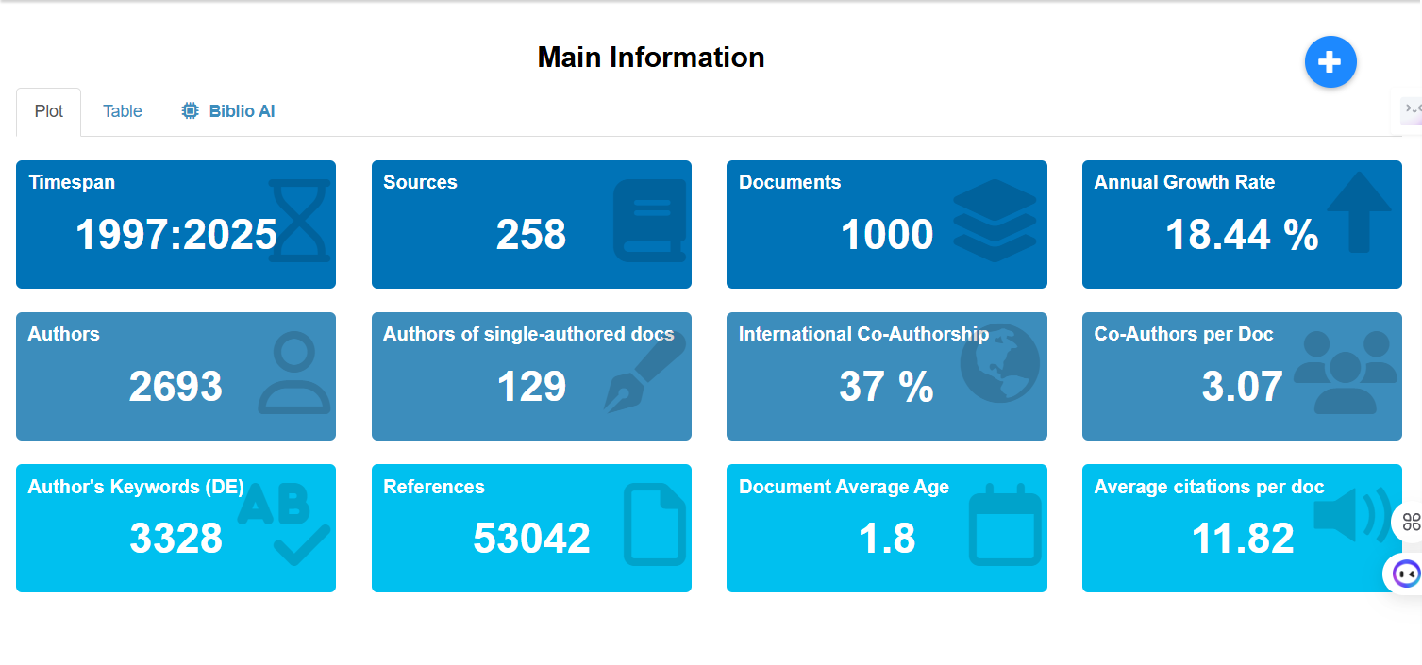
Fig. 3. Main Information.

4.1.2 Most Prolific Authors
The total publication numbers along with their corresponding fractionalized contributions (shown in Fig. 4 and Table 1) identify the author's productive output based on Lotka's Law, which portrays a few extremely productive authors and long tail of less productive authors. The top of the list of authors producing numerous publications is defined by Quach, S. and Thaichon, P., who each published 10 articles indicating continued interaction across the various areas of study within the SSCDF.
Authors' citation based indicators reflect corresponding levels of influence as well. For example, Chatterjee, S. has published eight articles and has a total of 427 citations, and, therefore, shows a good level of citation impact; whereas, Dwivedi, Y.K., who has only published four articles, has an unusually high number of 520 citations attributed to his articles, showing that Dwivedi's level of impact is more related to the concept behind his work rather than the quantity of articles published. Overall, our findings indicate that authors make contributions to their influence, both through ongoing contributions and contributions to the theoretical foundations of research within the SSCDF.
The relationship of the authors to each other within the research network is demonstrated in Fig. 4, and the author productivity based on the various indicators discussed in the previous paragraphs are summarized in Table 1.
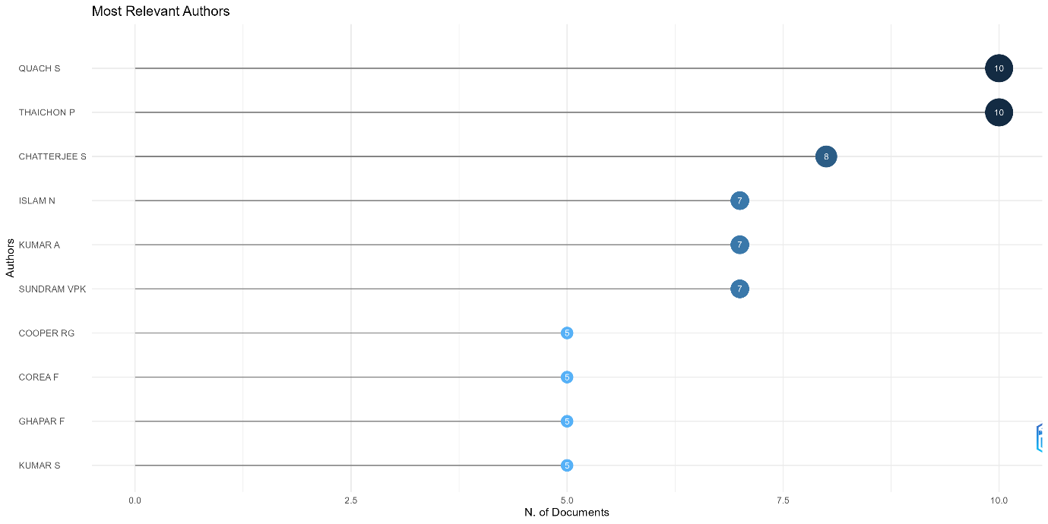
Fig. 4. Most Relevant Authors.

Table 1
Most Relevant Authors.
Authors | Articles | Articles Fractionalized
QUACH S | 10 | 3.17
THAICHON P | 10 | 3.17
CHATTERJEE S | 8 | 2.25
ISLAM N | 7 | 1.74
KUMAR A | 7 | 1.90
SUNDRAM VPK | 7 | 1.38
COOPER RG | 5 | 4.00
COREA F | 5 | 5.00
GHAPAR F | 5 | 0.93
KUMAR S | 5 | 1.67
VAN ESCH P | 5 | 1.83
VRONTIS D | 5 | 1.25
ZHANG J | 5 | 1.45
ALSHURIDEH M | 4 | 0.58
ALZOUBI HM | 4 | 0.58
APPIO FP | 4 | 1.03
BEHL A | 4 | 1.15
BREM A | 4 | 1.67
CHAUDHURI R | 4 | 0.92
DWIVEDI YK | 4 | 1.00
GUPTA S | 4 | 1.00

The geographical distribution of prolific authors demonstrates significant research output from areas like Europe and Asia. This prevalence is likely due to established academic systems, collaborative investments in artificial intelligence, and the rising importance of the digital supply chain revolution within these regions. In addition, many of the prolific authors have established global collaboration networks, which enhance the impact of citations. As a result of the multidisciplinary nature of SSCDF research — supply chain management, information systems, and machine learning — there were many opportunities for exceptional research output to originate from within these four geographical areas. However, differences between total and partial publications suggest shifts in collaboration intensity; in some cases, co-authorship networks were used primarily by other authors, while others formed more independently of one another.
4.1.3 Most Influential Institutions
Figure 5 and Table 2 presents the total number of publications and the strength of the collaborations each institution has made throughout its existence. The Indian Institute of Management (IIM System) ranks first amongst the institutions with 26 publications, highlighting the increase in the Indian institutional presence in machine learning (ML)-enabled operations and supply chain research. The next rankings are Symbiosis International University and the University of London contributing with 18 publications, respectively, further indicating geographical diversity across Asia and Europe.
The strength of collaborations from each institution will also tell another story of the total number of publications established by that institution. For example, the University of Jordan has a strong total link strength but has published a moderate number of publications. Therefore, the connection between universities from different countries is equally as important as those of the same geographical region. Swansea University has a very high citation impact relative to their output, indicating that its impact is conceptual in nature and not as productive in terms of volume.
As a result, the research from the SSCDF indicates that an institution's influence in the fields of operations and supply chain management will come from a mixture of publication output, citation impact, and collaboration data and not just volume by itself.
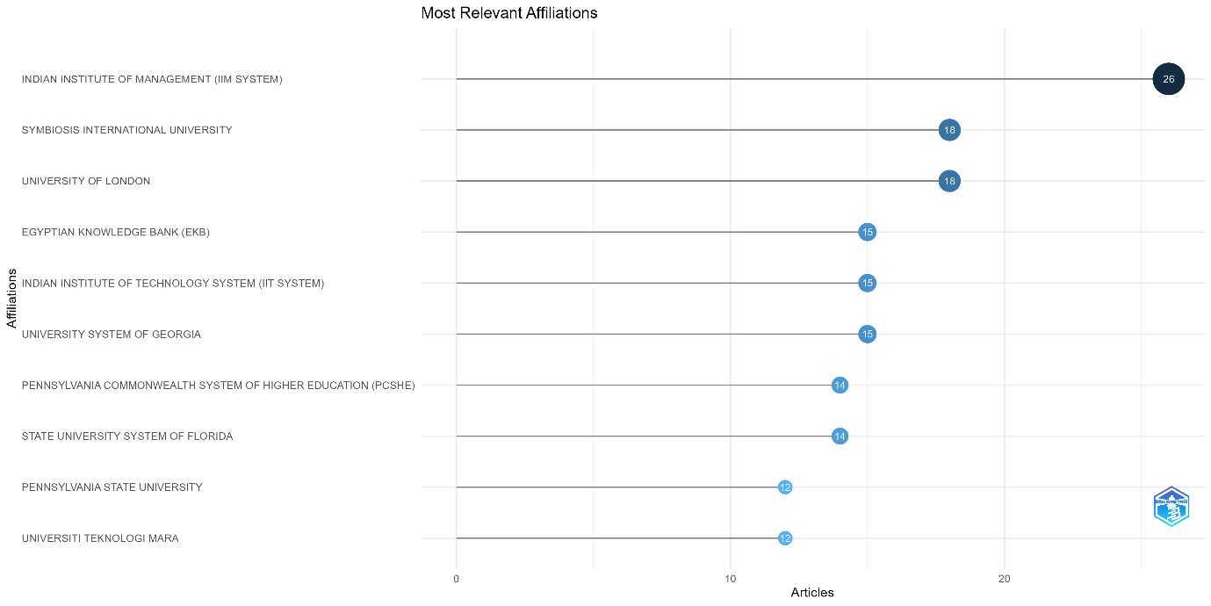
Fig. 5. Most Relevant Affiliations.

Table 2
Most Relevant Affiliations.
Affiliation | Articles
INDIAN INSTITUTE OF MANAGEMENT (IIM SYSTEM) | 26
SYMBIOSIS INTERNATIONAL UNIVERSITY | 18
UNIVERSITY OF LONDON | 18
EGYPTIAN KNOWLEDGE BANK (EKB) | 15
INDIAN INSTITUTE OF TECHNOLOGY SYSTEM (IIT SYSTEM) | 15
UNIVERSITY SYSTEM OF GEORGIA | 15
PENNSYLVANIA COMMONWEALTH SYSTEM OF HIGHER EDUCATION (PCSHE) | 14
STATE UNIVERSITY SYSTEM OF FLORIDA | 14
PENNSYLVANIA STATE UNIVERSITY | 12
UNIVERSITI TEKNOLOGI MARA | 12
UNIVERSITY SYSTEM OF OHIO | 12
CALIFORNIA STATE UNIVERSITY SYSTEM | 10
ISLAMIC AZAD UNIVERSITY | 10
UNIVERSITY OF JORDAN | 10
GRIFFITH UNIVERSITY | 9
HONG KONG POLYTECHNIC UNIVERSITY | 9
MINISTRY OF EDUCATION AND SCIENCE OF UKRAINE | 9
NATIONAL INSTITUTE OF TECHNOLOGY (NIT SYSTEM) | 9
NATIONAL UNIVERSITY OF SINGAPORE | 9
UNIVERSITY OF CALIFORNIA SYSTEM | 9
UNIVERSITY OF TEXAS SYSTEM | 9

4.1.4 Country-Level Contributions
Table 3 contains a summary of productivity and citation impact by country. The United States is by far the leader in total publications and citation counts, followed closely by China and India due to their strong academic-industry ties and the amount of funding invested into AI-enabled supply chains. The United Kingdom and Germany have lower total outputs, but significantly higher average citation rates than the others in Europe, which suggests a significant methodological or theoretical influence on researchers from these countries.
Emerging economies such as Brazil, the United Arab Emirates, and Qatar exhibit an average citation rate that would place them among those countries with high total output, but show less overall output than other countries; this may indicate that their contributions are very significant and contextually related to these specific countries. The results presented above indicate where researchers are having the most geographical impact, but do not make a determination about the relative quality of the research produced by each country or how effective their policies have been in utilizing AI to advance their economies.
Table 3
Country-Level Contributions.
Country | TC | Average Article Citations
USA | 1649 | 13.10
UNITED KINGDOM | 1223 | 17.00
CHINA | 1134 | 10.10
INDIA | 1018 | 10.60
BRAZIL | 950 | 73.10
GERMANY | 707 | 13.60
ITALY | 691 | 27.60
U ARAB EMIRATES | 482 | 32.10
FRANCE | 383 | 12.80
AUSTRALIA | 338 | 10.20
POLAND | 312 | 15.60
NETHERLANDS | 260 | 26.00
MALAYSIA | 227 | 9.10
QATAR | 220 | 55.00
CANADA | 165 | 9.70
AUSTRIA | 153 | 10.20
SWEDEN | 125 | 9.60
EGYPT | 123 | 13.70
NORWAY | 122 | 20.30
FINLAND | 119 | 8.50
DENMARK | 84 | 10.50

4.1.5 Leading Journals and Sources
Figure 6 and Table 4 display the publication volume for publications in the most important journals. The IEEE Transactions on Engineering Management had the most publications, followed by the other top publications of Technovation and Logistics-Basel. The analysis of Bradford's Law (in Figure 711) also displayed a core group of journals responsible for generating an excessive quantity of SSCDF articles.
Some other examples of journals that are intensely cited but have lower numbers of total articles published are the MIS Quarterly and the Technological Forecasting and Social Change, but they provide the foundation for research that is driven by theoretical perspectives and spans multiple disciplines.
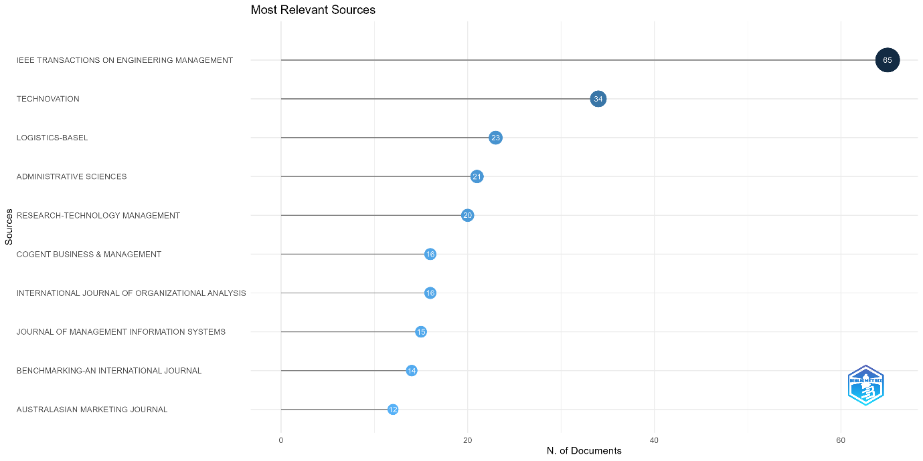
Fig. 6. Most Relevant Sources.

Table 4
Most Relevant Sources.
Sources | Articles
IEEE TRANSACTIONS ON ENGINEERING MANAGEMENT | 65
TECHNOVATION | 34
LOGISTICS-BASEL | 23
ADMINISTRATIVE SCIENCES | 21
RESEARCH-TECHNOLOGY MANAGEMENT | 20
COGENT BUSINESS & MANAGEMENT | 16
INTERNATIONAL JOURNAL OF ORGANIZATIONAL ANALYSIS | 16
JOURNAL OF MANAGEMENT INFORMATION SYSTEMS | 15
BENCHMARKING-AN INTERNATIONAL JOURNAL | 14
AUSTRALASIAN MARKETING JOURNAL | 12
EUROPEAN JOURNAL OF OPERATIONAL RESEARCH | 12
INFORMATION & MANAGEMENT | 12
JOURNAL OF SCIENCE AND TECHNOLOGY POLICY MANAGEMENT | 12
MANAGEMENT SCIENCE | 12
JOURNAL OF MANUFACTURING TECHNOLOGY MANAGEMENT | 11
PACIFIC BUSINESS REVIEW INTERNATIONAL | 11
TECHNOLOGY INNOVATION MANAGEMENT REVIEW | 11
YOUNG CONSUMERS | 11
ARTIFICIAL INTELLIGENCE, CO-CREATION AND CREATIVITY: THE NEW FRONTIER FOR INNOVATION | 10
HUMAN RESOURCE DEVELOPMENT INTERNATIONAL | 10

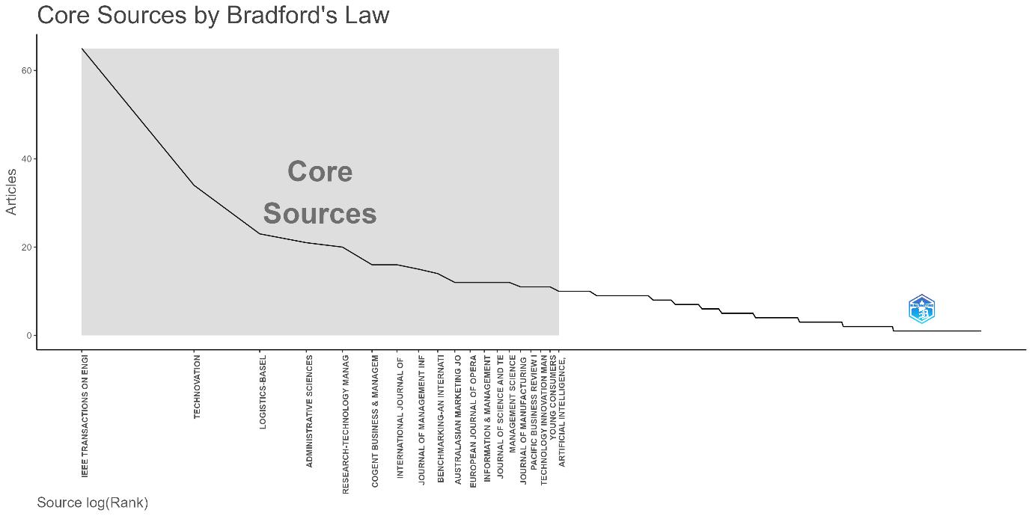
Fig. 7. Bradford’s Law.

4.2 Science Mapping Analysis
4.2.1 Co-occurrence of Keywords
Figure 8 is a representation of the co-occurrence network consisting of authors’ keywords, thus representing more than one keyword was required in a publication. Therefore, the minimum co-occurrence requirement provides a representation of the keyword co-occurrence network. The keyword clusters were assigned based on their descriptions of their most commonly occurring terms in the cluster, resulting in four distinct clusters:
(1) Applications of ML,
(2) Applications in Supply Chain and Logistics,
(3) Technological Enablers (big data, IoT, Industry 4.0), and
(4) Themes Associated with Performance and/or Adoption (trust, sustainability, resilience).
Finally, the temporal overlays include research that was primarily concerned with optimizing processes and analytics in real-time, while also incorporating a strong emphasis on adoption and sustainability-oriented subject matter. Thus, these data serve only to show evolution in thematic areas, and do not imply any future dominance.
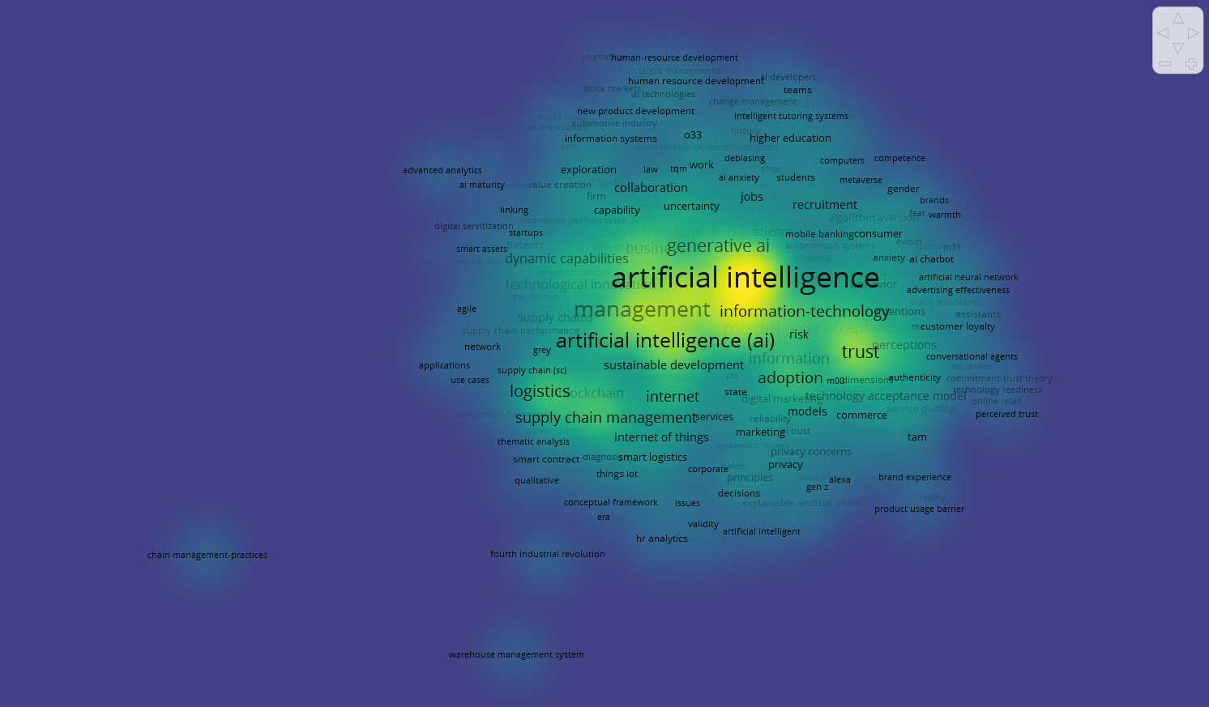
Fig. 8. Co-occurrence of Keywords.

4.2.2 Bibliographic Coupling

The bibliographic networks depicted in Fig. 9 show how documents and papers from different sources link through references to other documents and papers and can be identified by their clusters based on how many documents link back to each other. For example, the clustering includes the following aspects: digital transformation; ML Forecasting methods; Management adoption; and Sustainability/i.e., Resilience. The clusters were assigned based on how many documents were cited by other documents and the degree of overlap between the citations (Table 5 provides more details). These clusters represent a convergence of technical, managerial, and strategic aspects but do not imply a hierarchy between them being a top-down.
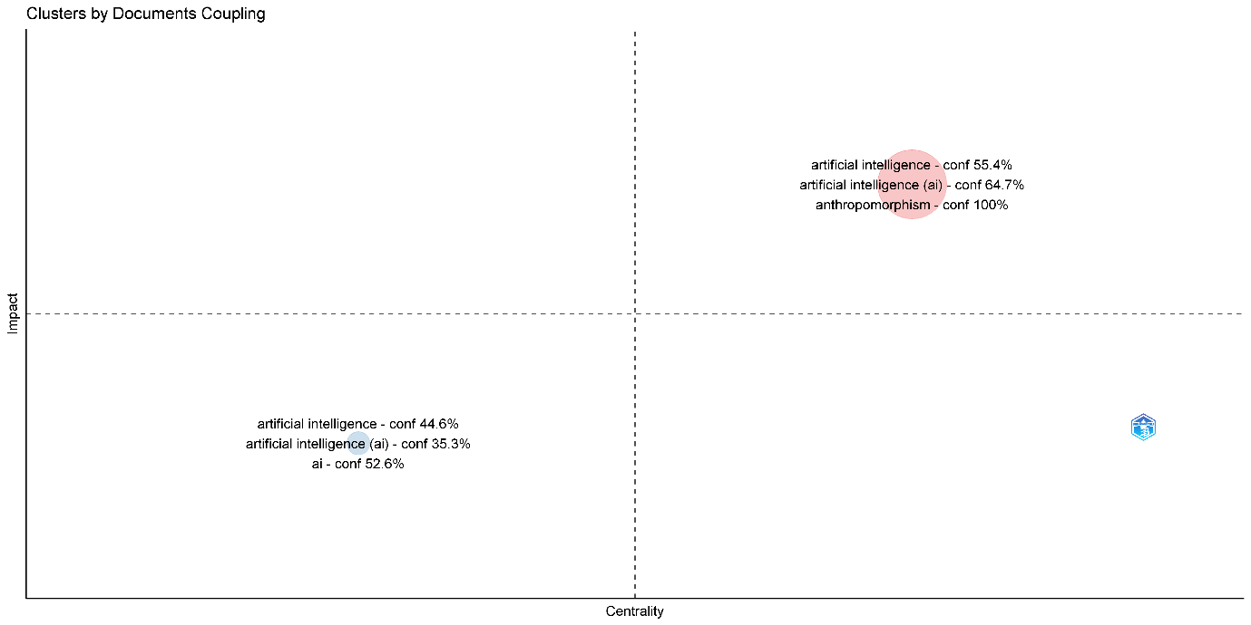
Fig. 9. Coupling.

Table 5
Coupling.
Documents | NormalizedLocalCitationScore | Cluster
Rana Np, 2022, Eur J Inform Syst | 6.67 | 1
Pillai R, 2020, Benchmarking | 6.61 | 1
Sharma S, 2024, Ieee T Eng Manage | 5.05 | 1
Chandra S, 2022, J Manage Inform Syst | 4.89 | 1
Chen Q, 2023, Internet Res | 4.41 | 1
Dennis Ar, 2023, J Manage Inform Syst | 4.41 | 1
Korzynski P, 2023, Cent Eur Manag J | 4.41 | 1
Malodia S, 2024, Ieee T Eng Manage | 4.33 | 1
Sharma S, 2024, Ieee T Eng Manage-A | 4.33 | 1
Chaudhuri R, 2023, J Fam Bus Manag | 3.78 | 1
Myin Mt, 2024, J Consum Mark | 3.61 | 1
Xu Yz, 2020, Australas Mark J | 3.56 | 1
Kinkel S, 2022, Technovation | 3.56 | 1
Cao Gm, 2021, Technovation | 3.32 | 1
Rana Np, 2024, Technovation | 2.89 | 1
Shore A, 2024, Technovation | 2.89 | 1
Singh K, 2024, Technovation | 2.89 | 1
Sattu R, 2024, J Organ Eff-People P | 2.17 | 1
Vo Dt, 2024, Young Consum | 2.17 | 1
Park Y, 2024, J Glob Scholars Mark | 2.17 | 1
Chin Ch, 2024, Young Consum | 2.17 | 1
Khan An, 2024, Ieee T Eng Manage | 2.17 | 1
Kang Jym, 2024, Int J Fash Des Techn | 2.17 | 1
Cheng Xs, 2024, Internet Res | 2.17 | 1
Olan F, 2024, Ieee T Eng Manage-A | 2.17 | 1

4.2.3 Co-citation Analysis
Fig. 10 illustrates a network of co-citation relationships and identifies the foundational works for the Intellectual Foundation of SSCDF research. In this network, each node has a size based on how often it is cited; each line connecting the nodes represents how frequently they co-cite one another; and each cluster has a different color indicating which studies are related to the studies in that cluster.
The purple cluster includes seminal studies conducted by Fornell (1981), Podsakoff et al. (1981), Hair et al. (1998), and Henseler (2015). These studies offer support for the methodological rigor of SSCDF research, focusing on structural equation modeling (SEM), measurement validation, and common method bias.

The blue cluster consists of studies by Dwivedi (2021), Huang (2018), and Kaplan (2019), which discuss technology adoption, digital transformation, and the integration of AI. This cluster provides theoretical grounding for the SSCDF in technology adoption and innovation literature.

The red cluster includes more current works, such as those of Benitez and Rausch from 2021, and of Haenlein from 2019, as well as machine-learning based applications/uses or tools, digital supply chains and/or approaches used for predicting or forecasting from analysis of data. They all contribute to the development of applied research on SSCDF topics.

The green cluster consists of works such as those of Luo, Wirtz and Puntoni that focus on AI, service systems, and client/customer analytics. Additionally these works provide links between technology and science and operationally and performance-based outcomes.

Overall, the network validates how SSCDF research is built upon strong methodological foundations, using Technology Adoption Theory as a framework, driving towards an increase in the use of ML and AI-based applications.

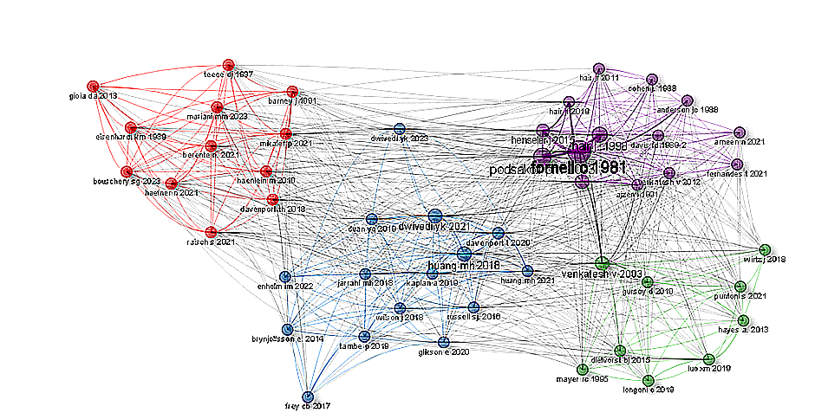

Fig. 10. Co-Citation.

4.2.4 Country Collaboration Networks
Figure 11 displays the international collaboration patterns between countries as nodes on the graph with each node linked to another country's node by a line; thus showing the two countries’ collaborative relationship, or co-authorship connections. The largest number of links between a single country is that of the United States to China, India and the United Kingdom; these links constitute the main collaborative hubs of these four regional groupings as illustrated by the diagram. The other highly linked regional groups are composed of European countries which form many smaller tightly connected clusters of countries, while the emerging markets contribute significant amounts of high-quality, low-volume, research output. Therefore, the results of the study provide an understanding of international research collaboration’s structure but do not indicate who is leading or dominating the research world.

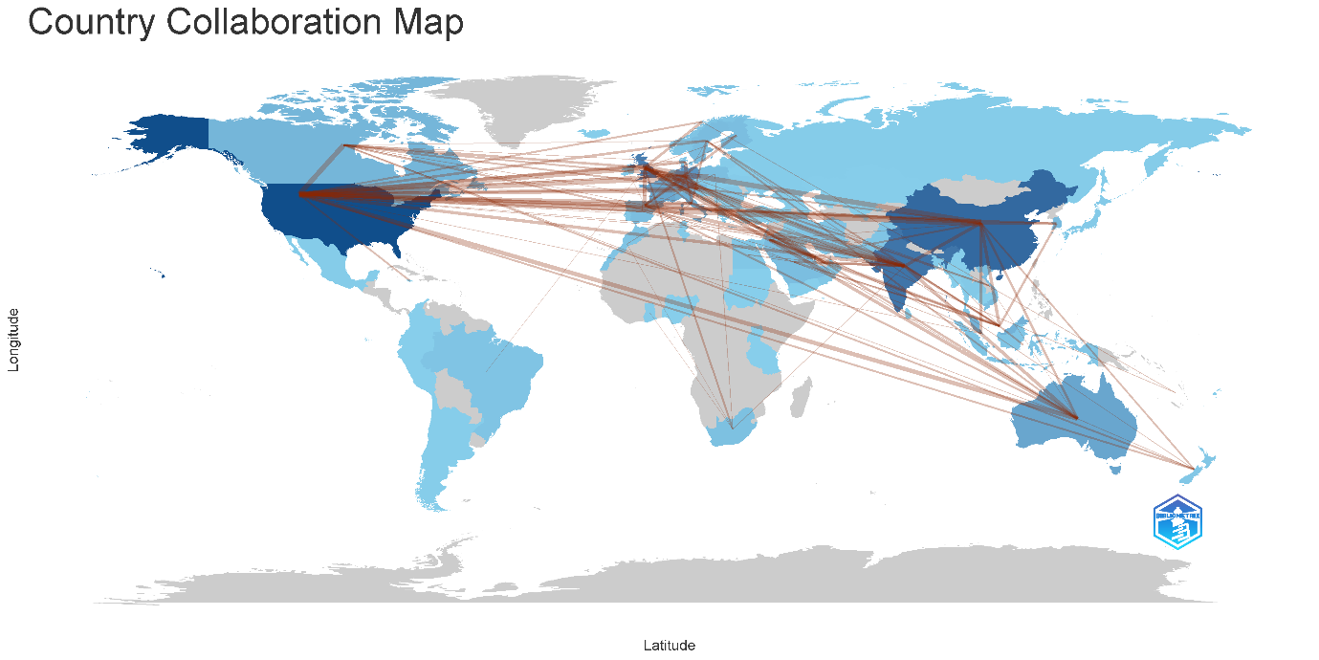
Fig. 11. Country Collaboration.

4.2.5 Thematic Map
Theme(s) and descriptions of them through their centrality (the relative involvement of each theme with the other themes) and density (how developed and consistent is the theme internally within itself) are shown in figure 12. A combination of these two centrality and density factors created four quadrants for theme evaluation. The upper right quadrant (motor theme) depicts themes that are both centrally located and have high levels of development or density. Themes that fall within this evaluation quadrant include machine learning, supply chain management and demand forecasting. Within this bibliometric analysis study, it can be inferred that artificial intelligence (artificial intelligent) can be classified as a dominant motor theme because AI-based methods are developed significantly more than other methods in the area of supply chain demand forecasting. The level of development of artificial intelligent-based research indicates to researchers that there are many developments of AI-based methods which are clustered together and add energy and excitement to the current international scientific community engaged in this area of research.
While established foundational themes of research will remain as core elements, the high degree of specialization seen in niche themes will continue. Meanwhile, emerging themes such as explainable AI, sustainability, and generative AI, reflect the ongoing re-prioritisation of research interests, meaning they are evolving in response to changing focus rather than being comprised of previously dominant areas.

The lower right quadrant of the above model represents basic themes; these are vital concepts that are key to virtually all studies, but have not yet been developed in great detail. For instance, 'impact', 'AI' and 'Performance' would be regarded as basic foundational themes, since they exhibit a high level of interdependence across the various disciplines included in this review, but are not yet well-defined as independent areas of study.
Niche themes are represented in the upper left quadrant where they show strong development and are also strongly related to one another. In this study, 'management', 'framework' and 'logistics' appear together as a well-defined cluster or niche theme. Although these themes demonstrate high levels of internal consistency, they are less frequently seen in the larger body of AI related studies and therefore are likely to represent specific domain areas or conceptual subfields.
The lower-left quadrant agrees to emerging or declining themes, categorized by low centrality and low density. In this map, this quadrant is moderately underpopulated, signifying that the field is comparatively mature, with less weakly developed or marginal themes.
Overall, the thematic structure highpoints the supremacy of AI-related concepts as the intellectual core of the field, reinforced by foundational performance-oriented themes and supplemented by specific logistics and management-oriented research rivulets.
\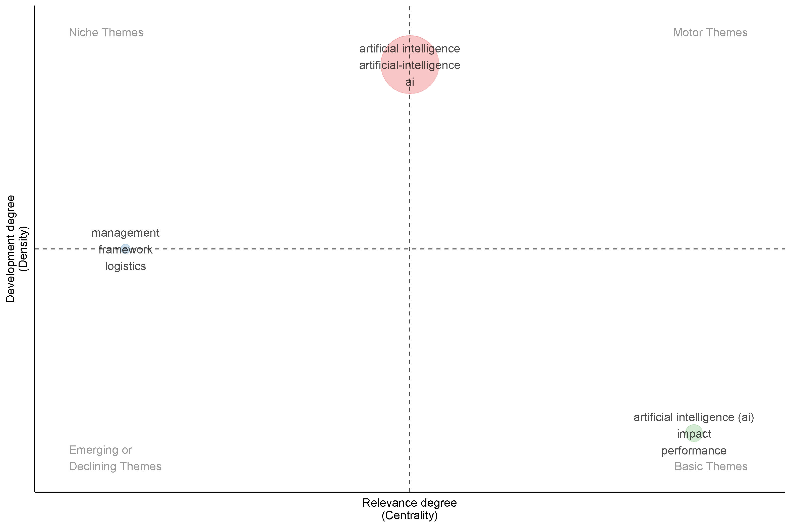
Fig. 12. Thematic Map.

4.3 Content Analysis
4.3.1 Key Research Themes Identified
The bibliometric and thematic analysis identify five research questions in the area of machine learning applications to advanced supply chain demand prediction. To make predictions more precise, a fair deal of effort is initially put in the development and assessment of machine learning models, such as deep learning, ensemble models, decision trees, neural networks, and SVM. Second, to model both linear and nonlinear demand patterns, hybrid methods, i.e. the combination of machine learning with the traditional statistical methods such as exponential smoothing and ARIMA, are increasingly being used. Third, there is the increasing significance of sector-specific applications in factories, logistics, and retail, where the primary goal is to enhance customer service and operational efficiency. Fourth, researchers are exploring scalable and real-time forecasting by incorporating auxiliary technology such as cloud platforms, big data, and the Internet of Things. Finally, performance analysis and uncertainty control remain essential, and emphasis should be placed on enhancing resilience to supply shocks and disruptions such as COVID-19 and making use of the effective forecasting methods, such as RMSE, MAPE, PICP, and PINAW.
The analysis of this material resulted in generalizing to five main concepts, which represent the cumulated intellectual structure used for the SSCDF research community. The first of these is Advanced Forecasting Methods Utilizing Advanced Machine Learning Technologies. There are significant advancements being made very rapidly relative to deep-learning and supervised-learning methods, many of which use Long Short Term Memory (LSTM), Convolutional (CNN), Random Forests, Gradient Boosting, and hybrid Neural Networks. Each of these models has proven effective for modeling complex and non-linear demand dynamics, seasonal demand patterns, and learning from very large numbers (high dimensional data), producing superior forecast quality versus traditional forecasting methods.The second theme, Hybrid Statistical -ML Approaches, brings into focus studies that combine the machine learning algorithms with the traditional time series models of ARIMA, ETS, and econometric models. These hybrid models attempt to combine the advantages of both paradigms in terms of the interpretability of statistical models and the fact that ML models can learn nonlinear relationships, thus offering stronger and more consistent forecasting performance to different demand situations.
The third theme, Sector-Specific Implementations, is based on the increasing significance of domain-adaptive forecasting systems specific to retail, logistics, manufacturing, agriculture, fashion, and e-commerce industries. The apps respond to the industry-specific issues, such as demand variability, perishability, promotions, seasonality, and responsive consumer behaviour. The fourth theme is Real-Time, Scalable Forecasting, which is motivated by the introduction of IoT sensors, RFID systems, big data pipes, and cloud computing models that allow capturing, processing, and updating forecasts in real-time. The transition from the traditional forecast models with limited functionality and the ability to provide historical forecasts to dynamic, automated forecasts with the ability to make forecasts at the moment of decision has been presented through the fifth theme that encompasses the importance of accurately establishing forecast accuracy through the use of RMSE, MAPE, MAE, and new and varied interval-related metrics of PICP and PINAW. These measures of their appropriate validation are not limited to the accuracy of the forecasts they produce but also to their ability to withstand uncertainty and interruption and for that matter, changes in the expected demand due to structure. The combination of these five themes can explain the evolving and broad research context where the methodological innovation, domain-specific adaptation, real-time analytics, and strong evaluation are at the core of improving the application of ML-driven demand forecasting.

4.3.2 Intellectual Structure of the Field
Theme 1: Demand Forecasting with Machine Learning Approaches
Literature demonstrates that common models of deep learning (including CNN and LSTM) and supervised learning techniques (support vector regression, random forest and gradient boosting) are popular in demand forecasting. Co-citation clusters refer to Rana (2022) and Xu (2020) as methodological innovators. Also, hybrid frameworks, between machine learning and optimisation frameworks, are gaining popularity because they enhance the interpretability and accuracy.
This theme describes the progress in machine learning algorithms to simulate the demand patterns in complicated supply chains. The studies within this stream are aimed at deep learning models (e.g., LSTM, GRU, CNN), ensemble classes (e.g., Random Forest, Gradient Boosting), attention-based models, and hybrid neural networks that are able to learn nonlinear and seasonal dynamics. Research demonstrates that improving prediction accuracy, managing high-dimensional data, providing probabilistic prediction capabilities, and optimizing models for environments with high volatility and uncertainty are the four main areas of focus for SSCDF research. These four key areas will be used as the basis for measuring the methodology of SSCDF research.

Theme 2: Uses in Manufacturing, Logistics, and Retail
Forecasting in supply chains that use machine learning (or ML) to support manufacturing facilities for factory planning, distribution logistics (supply and inventory logistics), and retail demand forecasting (e.g. grocery and fashion supply chains) are key areas for ML-based research. Per the search for keywords associated with the ML research performed, logistics, inventory management and retail are the most common areas of application for ML-based supply chain demand forecasting models.
This theme explores how ML models are integrated into the actual supply chain operations. It has been used in demand-driven inventory planning, lead-time forecasting, logistics routing, last-mile delivery optimisation, warehouse management, and production scheduling. The emphasis lies on the feasibility of an operation, cost-cutting, the performance of the service level, and the managerial issues of the usage of ML systems in practice. This stream is a bridging point between theoretical models and the actual decision-making in different supply chain situations.

Theme 3: Cloud Platform, Big Data, and IoT Integration
The growing availability of real-time sensor and transactional data has also positively impacted the interest in IoT-enabled and big data-driven forecasting models. Research has demonstrated that applying machine learning to supply chain demand forecasting enables greater scalability and greater interoperability when combined with cloud-based technologies. Additionally, clusters that relate to digital transformation and Industry 4.0 demonstrate the impact new technologies will have on supporting intelligent forecasting systems.
This theme highlights the infrastructure technologies that allow for scalable, real-time forecasting systems. The technologies include the Internet of Things (IoT) sensors, RFID, enterprise cloud platforms and big-data architecture systems, all of which provide continuous streams of raw transactional and sensor data. These technologies can be trained to build large models while continually receiving data in real-time through platform integration. Research studies in this theme examine how digital connectivity can create predictive visibility, real-time monitoring, and dynamic decision-making across the supply chain.
Theme 4: Metrics for Forecasting Evaluation
Evaluation metrics, such as RMSE (Root Mean Square Error), MAPE (Mean Absolute Percentage Error), MAE (Mean Absolute Error), as well as more advanced uncertainty quantification methods such as PICP (Prediction Interval Coverage Probability) and PINAW (Prediction Interval Normalized Average Width), are routinely used by the body of knowledge. The commitment to enhancing accuracy aligns with the goals of managers to reduce costs, improve service levels, and decrease stockouts.
The theme is concerned with the measurement of the strength and accuracy of ML forecasting models. Research assesses performance in terms of error-based (RMSE, MAPE, MAE) and uncertainty-based (PICP, PINAW, CRPS). Other studies are on model stability, interpretability, cross-validation, and hardiness to disruption situations. This stream is in place to guarantee that the methods of ML forecasting are scientifically valid, resistant to noise in data, and reliable in supporting mission-critical supply chain decision-making.

Theme 5: New Developments
Several new frontiers are highlighted by recent keyword bursts and thematic mapping:
Explainable AI (XAI): Resolving the “black-box” aspect of machine learning models and enhancing managers’ capacity to understand them.
Forecasting sustainability involves tying waste minimisation, eco-friendly supply chains, and green logistics to demand forecasting.
Supply chains that are resilient include risk reduction techniques, disruption management (such as COVID-19 and geopolitical shocks), and forecasting under uncertainty.
Digital twins and generative AI: preliminary findings of studies combining simulation and generative modelling for demand planning.
The last theme will discuss the research areas that are emerging, which define the future of ML in supply chains. Explainable AI (XAI) seeks to enhance managerial trust and adoption by expanding on the issue of transparency and interpretability of decisions. Forecasting that is focused on sustainability incorporates carbon footprint reduction, waste minimisation, and the goals of the circular economy. Digital twin Systems are used to recreate supply chain environments to test scenarios, disruption models, and plan resilience. Synthetic demand generation, stress-testing forecasting models, and assistive adaptive planning are all done by generative AI methods (e.g., diffusion models, GANs). These frontier
4.3.3 Comparison of ML Forecasting Methods.
Studies on SSCDF show that the classical statistical forecasting methods have been gradually transformed into more sophisticated models of machine learning and deep learning. The classical techniques like ARIMA, SARIMA, and exponential smoothing still remain as relevant benchmarks given their transparency and the capacity to capture the linear trends and seasonality patterns. Their shortcomings are, however, evident in the case of nonlinear, multivariate, or highly volatile demand. Machine learning methods such as the Random Forest, the Gradient Boosting, and the Support Vector Machines are more flexible to use since they can use more exogenous variables, which makes them perform better in the complex operational settings. Deep learning models, such as LSTM, GRU, CNN, and Transformer-based architectures, are currently regarded as the top choices for modeling long-term relationships, non-linearities, and high-dimensional interactions in supply chain data. Hybrid approaches and combining them with statistical linear approaches also improve the ability to predict using forecast models due to the creation of models containing both linear statistical and non-linear ML layers that provide statistical models that have both moderate predictive capabilities and moderate interpretable qualities. On the whole, the literature reveals that more advanced architectures are being embraced as more data volume, diversity, and speed in the supply chain are being generated.
4.3.4 Evaluation Metrics
In SSCDF, the evaluation practices are still focused on the point-based accuracy measures like RMSE, MAE, and MAPE, which are commonplace because they are simple and easy to compare. RMSE is commonly used because it is sensitive to large events, which implies that it can be applied in high-risk forecasting situations, whereas MAE is used due to its strength and interpretation capability. MAPE is still used but is well known to give skewed values in cases where volumes of demand are small or intermittent. More sophisticated statistics like MASE and RMSSE can be found in more recent literature to make scale-free comparisons between two or more demand series. Nevertheless, the introduction of probabilistic and uncertainty-sensitive metrics, including PICP, PINAW, and CRPS, is not extensively used, even though their use also becomes more complex according to the existing forecasting models. This does not coincide with the resilience and risk management interest in the field. On the same note, business-oriented measures like service level, fill rate, stock out probability and inventory cost are rarely included which creates disconnection between predictive accuracy and operational impact. This literature thus suggests that there should be increased effort towards more holistic assessment frameworks that bridge the gap between statistical accuracy and probabilistic calibration with domain specific supply chain performance measures.

5. Discussion
This bibliometric review augments previous systematic reviews that mainly focused on the algorithmic performance or comparisons with traditional statistical forecasting methods which often struggle with the capacity of modeling the nonlinear demand patterns in complex supply chains (Aamer et al., 2021). By associating bibliometric evidence against the research questions posed in this study, the discussion ties the bibliometric evidence with the substantive insight.
RQ1 assessed the development of SSCDF research across time and place. The publication and citation analyses have shown a change from exploratory experimentation to a field of high growth research development between the years 1997-2025 with a growth rate of about 18% per annum. The results also show geographic concentration of the research, especially in the United States, China and India as a measure of current geographic strength of methodological leadership and institutional capacity.
RQ2 focused on identifying the intellectual structure, dominant research themes, of SSCDF. Science-mapping analyses (keyword co-occurrence, bibliographic coupling and co-citation) indicate that there are four interrelated clusters in the scientific literature: ML-based forecasting models, supply chain and logistics use cases, digital-enabling technology and adoption and performance-related topics. These findings have shown the research of SSCDF is no longer solely algorithmic in nature but increasingly socio-technical, which incorporates organizational, behavioral and strategic perspectives.
RQ3 considered future emerging themes and research priorities. The thematic map shows that explainable AI, sustainability, resilience and generative AI represent developing themes with increasing centrality yet decreasing maturity that suggest the direction where future research efforts may be focused. These themes endorse a transition away from forecasting systems designed for efficiency and towards ones that are responsible, interpretable and resilient decision support systems.
From the managerial perspective, the results indicate that organizations aiming to implement hybrid models, neural networks or IoT-enabled forecasting systems will need to focus on developing strong data infrastructures and ensuring integration into the cloud environment as well as algorithmic flexibility (Saha et al., 2024). From policy information, the helter structures as a small number of countries, the importance of initiatives promoting international and capacity building in reduced-represented regions (Daios et al., 2025). Overall, the discussion shows how the bibliometric analyses directly respond to the research questions and give an integrated picture of the development, pattern and future orientation of SSCDF scholarship.
6. Future Research Directions & Limitations
6.1 Suggestions for Future Research
With the clusters and thematic evolution as a basis, a number of encouraging avenues for research are thus opened up. First, sustainability-oriented forecasting is one of the important avenues, especially the combination of the ML-based demand prediction with Green logistics and circular economy principles. Second, more research on human and AI collaboration aimed at adoption and focused on managerial trust, transparency and acceptance of AI-based forecasting systems should be encouraged.
Third, it is the integration of IoT, big data platforms and streaming or online learning frameworks that is key to moving to a future where we have more real-time demand sensing in more volatile environments. Fourth, disruption-aware forecasting - including dealing with pandemics, geopolitducible shock and climate-related risks - are still underexplored and require more attention using scenario planning and uncertainty-aware models. The last thing the research mention about cross-region comparison studies is that they can help build theory in both Africa, Latin America and the Middle-East through improved contextual diversity and thus, help develop a larger body of knowledge.
6.2 Limitations
Many limitations affect the strength of this study. For example, the entire data set consists of just 1,000 total articles available to search from the Web of Science database (WoS) — different databases contain other information which can result in a lack of relevant articles (i.e. algorithms not being translated into other databases) based on available data. Second, citation-based indicators are affected by time lag of effects so that influence of latest published in 2023 to 2025 will be under-represented.
Third, however, is that the scope of the search query has an associated limitation. While screening criteria was applied to narrow down on supply chain demand forecasting, the corpus may contain studies that have a broad connection with AI in supply chains and not necessarily those of forecasting applications, which may dilute SSCDF-focused conclusions. To mitigate this risk, the study is based on forecasting (dominant keyword clusters and thematic structures), whereas future studies could be designed to increase robustness through e.g. applying narrow query strings or conducting sensitivity analysis lumping only the forecasting-centric terms.
Finally, the methodological approaches used in bibliometrics have limited ability in outlining the scholarly structures and are not capable of assessing the real-world predictive capability of ML algorithms in real-world supply chain applications.
6.3 Future Directions
Future SSCDF research needs to focus more on probabilistic forecasting and uncertainty quantification, due to the high operational cost of forecast errors. Real-time and streaming learning frameworks and IoT, edge computing and big-data infrastructures should become the norm. Examples of areas where we see improvement from using explainable artificial intelligence (XAI) include creating more transparent, trustworthy, and easily accepted systems by managers. The future XAI framework will encompass several different components to create better quality forecasting while still allowing interpretive features to help explain the decision-making process for stakeholders (e.g. inventory constraints, lead times, etc.) represented by machine-learning routes to better reconcile quality with quality.
Lastly, creating open benchmark data sets and using standardized evaluation protocols across multiple research domains would help improve reproducibility of results and allow for comparisons between studies. More attention should be focused on multi-objective forecasting models that incorporate sustainability metrics such as carbon emissions and waste reduction and on intermittent-demand situations. Together, these directions indicate a shift towards a future where realism in operations, human-centric interpretability, and sustainability in decision-making become denizing aspects of next generation SSCDF research.
7. Conclusion
Based on an analysis of 1000 publications that were drawn from Web of science management category sources published during the period of time 1997-2025, this bibliometric review provides a comprehensive mapping of the intellectual structure and evolution of machine learning (ML) applications in smart supply chain demand forecasting (SSCDF). The results show a continuous and accelerating increase in the academic production, especially after 2018 with a growth rate of 18.44% annually which shows that SSCDF has evolved from an exploratory topic to a very active research topic in the context of operations and supply chain management. While it is true that this growth occurs controversially proved at the temporal contribution of Industry 4.0 technologies or major supply chain disruptions, the bibliometric evidence seems in favor of detecting growth patterns rather than cause and effect.
The results of the performance analysis reveal the presence of a dual structure of influence in the field. There are only a few very productive authors such as Quach, Thaichon, and Chatterjee who provide consistent academic contributions. On the other hand, there are many authors such as Dwivedi and Islam whose conceptual impact is very high compared to the number of citations they receive because of their fundamental contributions. On an institutional level, the Indian Institute of Management emerges as one of the leading institutions that have contributed immensely to research productivity, whereas Swansea University and Auckland University of Technology have high scores on citation impact based on output and volume. Country-level analysis shows that the United States, China, and India lead the production of research with other smaller research systems like Brazil, the United Arab Emirates, and Qatar contributing accordingly high impact, context-specific research, reflecting the variety in, but uneven form of SSCDF scholarship around the world.
The basic contribution of this study is the mapping of science in this research. Keyword co-occurrence, bibliographic coupling, co-citation, and thematic mapping show that SSCDF research is organized into four interconnected clusters: forecasting models based on ML, applications of Supply Chain and Logistics, Technologies that support the digital causes, and themes that focus on adoption and performance elements. Unlike previous narrative reviews that principally consider the performance of algorithms, this review shows how the field has developed as a socio-technical research field, where the question of how accurately algorithms forecast their predictions is increasingly being considered alongside other factors, including organizational acceptance, trust, sustainability, and resilience.
The thematic map further shows that machine learning and demand forecasting represent a long-standing set of motor themes and that explainable AI, sustainability, resilience, and generative AI represent a developing set of motor themes with increasing relevance but lower maturity, proposing that they are in advance significance but they lack in the concept process and development of methodology.
This bibliometric study delivers managerial understanding by focusing on where research attention is more dominated and where the gaps persist. The managers should adopt robust forecasting methods to enhance the effective decision-making process without uncertainty. The growing need for resilience and sustainability for a conducive environment for better supply chain strategies.
By integrating the linking between thematic evolution and practical implications, the study focuses beyond descriptive results and reveals how bibliometric analysis can enhance effective managerial decision-making. Moreover, it demonstrates an important technology for implementation and future development. This study contributes to the importance of SSCDF research while providing significant guidelines for researchers, policymakers and practitioners in designing efficient supply chain strategies.
.
Data Availability
The bibliographic dataset and supporting materials used in this study are available in the GitHub repository:
https://github.com/mohnishusr/ML-SupplyChain-Bibliometric-Study/
The repository includes the Web of Science search query, bibliometric analysis parameter settings, PRISMA screening information.
Funding
The university funds this project where the corresponding author works.
Declaration of Generative AI
No generative AI tools were used to generate scientific content, figures, graphical abstracts, or images in this study.

AI-assisted tools were used only for minor language editing. All analyses, visualizations, and interpretations were performed by the authors.

8. References
Aamer, A. M., Putu, L., Yani, E., Made, I., & Priyatna, A. (2021). Data Analytics in the Supply Chain Management: Review of Machine Learning Applications in Demand Forecasting. OPERATIONS AND SUPPLY CHAIN MANAGEMENT, 14(1), 1–13.
Admoko, D. A., Darmawan, B., Ana, A., & Dwiyanto, V. (2024). A Cluster-Based Bibliometric Analysis of the Emerging Technological Landscape in Logistics using Vosviewer. Journal of Advanced Research in Applied Sciences and Engineering Technology, 42(2), 234–249. https://doi.org/10.37934/araset.42.2.234249
Aldahmani, E., Alzubi, A., & Iyiola, K. (2024). Demand Forecasting in Supply Chain Using Uni-Regression Deep Approximate Forecasting Model. Applied Sciences (Switzerland), 14(18). https://doi.org/10.3390/app14188110
Aljabhan, B. (2023). Economic strategic plans with supply chain risk management (SCRM) for organizational growth and development. Alexandria Engineering Journal, 79, 411–426. https://doi.org/10.1016/j.aej.2023.08.020
Barreto, L., Amaral, A., & Pereira, T. (2017). Industry 4.0 implications in logistics: an overview. Procedia Manufacturing, 13, 1245–1252. https://doi.org/10.1016/j.promfg.2017.09.045
Barzizza, E., Biasetton, N., Ceccato, R., & Salmaso, L. (2023). Big Data Analytics and Machine Learning in Supply Chain 4.0: A Literature Review. In Stats (Vol. 6, Issue 2, pp. 596–616). MDPI. https://doi.org/10.3390/stats6020038
Belu, M. G., & Marinoiu, A. M. (2025). AI-Enabled Supply Chain Management: A Bibliometric Analysis Using VOSviewer and RStudio Bibliometrix Software Tools. Sustainability (Switzerland), 17(5). https://doi.org/10.3390/su17052092
Bigliardi, B., Casella, G., & Bottani, E. (2021). Industry 4.0 in the logistics field: A bibliometric analysis. In IET Collaborative Intelligent Manufacturing (Vol. 3, Issue 1, pp. 4–12). John Wiley and Sons Inc. https://doi.org/10.1049/cim2.12015
Cancino, C. A., Amirbagheri, K., Merigó, J. M., & Dessouky, Y. (2019). A bibliometric analysis of supply chain analytical techniques published in Computers & Industrial Engineering. Computers and Industrial Engineering, 137. https://doi.org/10.1016/j.cie.2019.106015
Charvet, F. F., Cooper, M. C., & Gardner, J. T. (2008). THE INTELLECTUAL STRUCTURE OF SUPPLY CHAIN MANAGEMENT: A BIBLIOMETRIC APPROACH. Journal of Business Logistics, 29(1), 47–73. https://doi.org/10.1002/j.2158-1592.2008.tb00068.x
Daios, A., Kladovasilakis, N., Kelemis, A., & Kostavelis, I. (2025). AI Applications in Supply Chain Management: A Survey. In Applied Sciences (Switzerland) (Vol. 15, Issue 5). Multidisciplinary Digital Publishing Institute (MDPI). https://doi.org/10.3390/app15052775
Ferreira, B., & Reis, J. (2023). Artificial Intelligence in Supply Chain Management: A Systematic Literature Review and Guidelines for Future Research. Springer Proceedings in Mathematics and Statistics, 431, 339–354. https://doi.org/10.1007/978-3-031-47058-5_27
Hamdaoui, T., & Aknin, N. (2025). The Role of Artificial Intelligence in Supply Chain Finance in the Context of Industry 5.0: A Systematic Literature Review. 25. https://doi.org/10.3390/engproc2025097025
Jung, S., Kim, H., & Kang, C. (2025). Efficiency Analysis of the Integrated Application of Hazard Operability (HAZOP) and Job Safety Analysis (JSA) Compared to HAZOP Alone for Preventing Fire and Explosions in Chemical Plants. Processes, 13(1). https://doi.org/10.3390/pr13010088
Le, T. V, & Fan, R. (2023). Digital Twins for Logistics and Supply Chain Systems: Literature Review, Conceptual Framework, Research Potential, and Practical Challenges.
Lei, C., Zhang, H., Wang, Z., & Miao, Q. (2025). Deep Learning for Demand Forecasting: A Framework Incorporating Variational Mode Decomposition and Attention Mechanism. Processes, 13(2). https://doi.org/10.3390/pr13020594
Malacina, I., & Teplov, R. (2022). Supply chain innovation research: A bibliometric network analysis and literature review. In International Journal of Production Economics (Vol. 251). Elsevier B.V. https://doi.org/10.1016/j.ijpe.2022.108540
Mañay, L. O. R., Rodríguez, O. V., León, J. A. P., & Pérez, J. A. D. (2024). Supply Chains and Artificial Intelligence: An Approach to the State of the Art. Journal of Scientometric Research, 13(2), 382–395. https://doi.org/10.5530/jscires.13.2.30
Mediavilla, M. A., Dietrich, F., & Palm, D. (2022). Review and analysis of artificial intelligence methods for demand forecasting in supply chain management. Procedia CIRP, 107, 1126–1131. https://doi.org/10.1016/j.procir.2022.05.119
Mittapally, R. (2025). Evaluating Machine Learning Techniques for Demand Forecasting in Supply Chains Using MOORA Method. Journal of Artificial Intelligence and Machine Learning, 3(1), 1–13. https://doi.org/10.55124/jaim.v3i1.259
Narwane, V. S., Raut, R. D., Mangla, S. K., Dora, M., & Narkhede, B. E. (2023). Risks to Big Data Analytics and Blockchain Technology Adoption in Supply Chains. Annals of Operations Research, 327(1), 339–374. https://doi.org/10.1007/s10479-021-04396-3
Nikolopoulos, K. (2021). We need to talk about intermittent demand forecasting. European Journal of Operational Research, 291(2), 549–559. https://doi.org/10.1016/j.ejor.2019.12.046
Noman, A. A., Akter, U. H., Pranto, T. H., & Haque, A. K. M. B. (2022). Machine Learning and Artificial Intelligence in Circular Economy: A Bibliometric Analysis and Systematic Literature Review. In Annals of Emerging Technologies in Computing (Vol. 6, Issue 2, pp. 13–40). International Association for Educators and Researchers (IAER). https://doi.org/10.33166/AETiC.2022.02.002
Pan, H., Zou, N., Wang, R., Ma, J., & Liu, D. (2025). Artificial Intelligence Usage and Supply Chain Resilience: An Organizational Information Processing Theory Perspective. Systems, 13(9), 724. https://doi.org/10.3390/systems13090724
Patalas-Maliszewska, J., Szmołda, M., & Łosyk, H. (2024). Integrating Artificial Intelligence into the Supply Chain in Order to Enhance Sustainable Production—A Systematic Literature Review. In Sustainability (Switzerland) (Vol. 16, Issue 16). Multidisciplinary Digital Publishing Institute (MDPI). https://doi.org/10.3390/su16167110
Qu, C., & Kim, E. (2024). Reviewing the Roles of AI-Integrated Technologies in Sustainable Supply Chain Management: Research Propositions and a Framework for Future Directions. In Sustainability (Switzerland) (Vol. 16, Issue 14). Multidisciplinary Digital Publishing Institute (MDPI). https://doi.org/10.3390/su16146186
Rana, J., & Daultani, Y. (2023). Mapping the Role and Impact of Artificial Intelligence and Machine Learning Applications in Supply Chain Digital Transformation: A Bibliometric Analysis. Operations Management Research, 16(4), 1641–1666. https://doi.org/10.1007/s12063-022-00335-y
Ren, Y., Li, R., Wu, K. J., & Tseng, M. L. (2023). Discovering the systematic interlinkages among the circular economy, supply chain, industry 4.0, and technology transfer: A bibliometric analysis. Cleaner and Responsible Consumption, 9. https://doi.org/10.1016/j.clrc.2023.100123
Riahi, Y., Saikouk, T., Gunasekaran, A., & Badraoui, I. (2021). Artificial intelligence applications in supply chain: A descriptive bibliometric analysis and future research directions. In Expert Systems with Applications (Vol. 173). Elsevier Ltd. https://doi.org/10.1016/j.eswa.2021.114702
Saha, R., Shofiullah, S., Faysal, S. A., & Happy, A. T. (2024). SYSTEMATIC LITERATURE REVIEW ON ARTIFICIAL INTELLIGENCE APPLICATIONS IN SUPPLY CHAIN DEMAND FORECASTING. ACADEMIC JOURNAL ON BUSINESS ADMINISTRATION, INNOVATION & SUSTAINABILITY, 4(04), 109–127. https://doi.org/10.69593/ajbais.v4i04.136
Salinas, D., Flunkert, V., Gasthaus, J., & Januschowski, T. (2020). DeepAR: Probabilistic forecasting with autoregressive recurrent networks. International Journal of Forecasting, 36(3), 1181–1191. https://doi.org/10.1016/j.ijforecast.2019.07.001
Samuels, A. (2024). Examining the integration of artificial intelligence in supply chain management from Industry 4.0 to 6.0: a systematic literature review. In Frontiers in Artificial Intelligence (Vol. 7). Frontiers Media SA. https://doi.org/10.3389/frai.2024.1477044
Shamsuddoha, M., Khan, E. A., Chowdhury, M. M. H., & Nasir, T. (2025). Revolutionizing Supply Chains: Unleashing the Power of AI-Driven Intelligent Automation and Real-Time Information Flow. In Information (Switzerland) (Vol. 16, Issue 1). Multidisciplinary Digital Publishing Institute (MDPI). https://doi.org/10.3390/info16010026
Sharifpour, H., Ghaseminezhad, Y., Hashemi-Tabatabaei, M., & Amiri, M. (2022). Investigating cause-and-effect relationships between supply chain 4.0 technologies. Engineering Management in Production and Services, 14(4), 22–46. https://doi.org/10.2478/emj-2022-0029
Teixeira, A. R., Ferreira, J. V., & Ramos, A. L. (2025). Intelligent Supply Chain Management: A Systematic Literature Review on Artificial Intelligence Contributions. In Information (Switzerland) (Vol. 16, Issue 5). Multidisciplinary Digital Publishing Institute (MDPI). https://doi.org/10.3390/info16050399
Thakur, K., Maity, S., Nielsen, P., Pal, T., & Maiti, M. (2024). A 3D multiobjective multi-item eco-routing problem for refrigerated fresh products delivery using NSGA-II with hybrid chromosome. Computers and Industrial Engineering, 198. https://doi.org/10.1016/j.cie.2024.110644
Theodoridis, G., & Tsadiras, A. (2025). Retail Demand Forecasting: A Comparative Analysis of Deep Neural Networks and the Proposal of LSTMixer, a Linear Model Extension. Information (Switzerland), 16(7). https://doi.org/10.3390/info16070596
Tirkolaee, E. B., Sadeghi, S., Mooseloo, F. M., Vandchali, H. R., & Aeini, S. (2021). Application of Machine Learning in Supply Chain Management: A Comprehensive Overview of the Main Areas. In Mathematical Problems in Engineering (Vol. 2021). Hindawi Limited. https://doi.org/10.1155/2021/1476043
Zejjari, I., & Benhayoun, I. (2024). The use of artificial intelligence to advance sustainable supply chain: retrospective and future avenues explored through bibliometric analysis. In Discover Sustainability (Vol. 5, Issue 1). Springer Nature. https://doi.org/10.1007/s43621-024-00364-6

